Lab # 03
Relational Operators in C++
Objective:
To understand and implement relational operators to compare values in C++.
Theory:
Relational operators are used to compare two values or variables. The result of a relational expression is either true (1) or false (0).
- Common Relational Operators
- Operator
Meaning:
- Equal to
- Not equal to
- Greater than
- Less than
- Greater than or equal to
- Less than or equal to

Program:
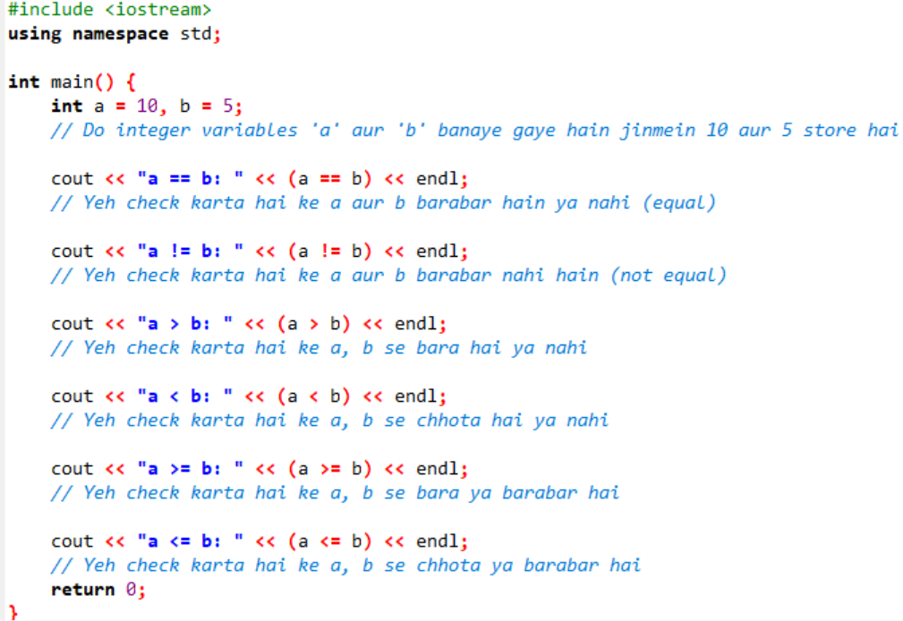

Output:
a == b: 0
a != b: 1
a > b: 1
a < b: 0
a >= b: 1
a <= b: 0

Conclusion:
Relational operators help in comparing values and are commonly used in decision-making statements.

Logical Operators in C++
Title:
Study and Implementation of Logical Operators in C++
Objective:
To understand and use logical operators to combine conditions.
Theory:
Logical operators are used to combine multiple conditions and return a boolean result.
Types of Logical Operators:
- Operator
Meaning
- Logical AND
- Logical NOT
Program:
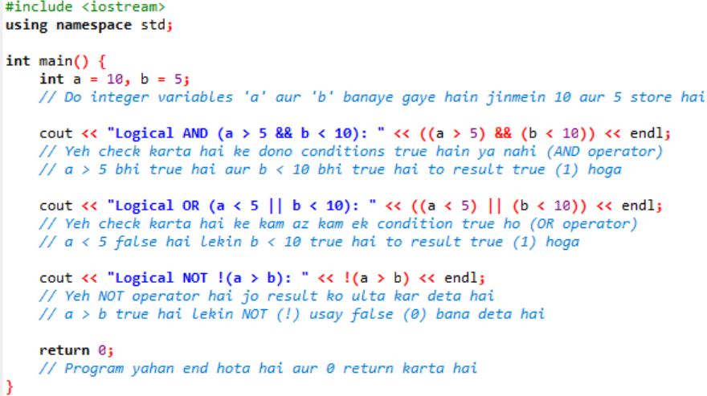
Output:
Logical AND: 1
Logical OR: 1
Logical NOT: 0
Conclusion:
Logical operators are useful for combining multiple conditions in programs, especially in decision-making.

Conditional Statements in C++
Title:
Study and Implementation of Conditional Statements in C++
Objective:
To understand decision-making using conditional statements like if, if-else, and switch.
Theory:
Conditional statements allow a program to make decisions based on conditions.
Types of Conditionals:
- if
- else if
- if-else
- switch

Program 1:
if-else
Code:
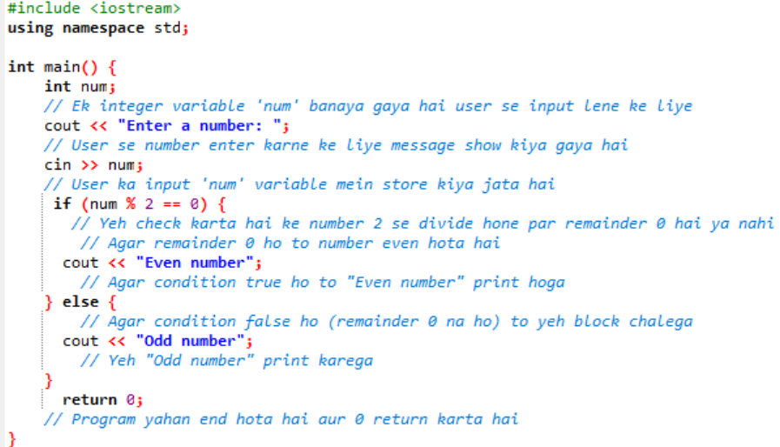
Program 2:
else-if
Code:

Program 3:
switch statement
Code:
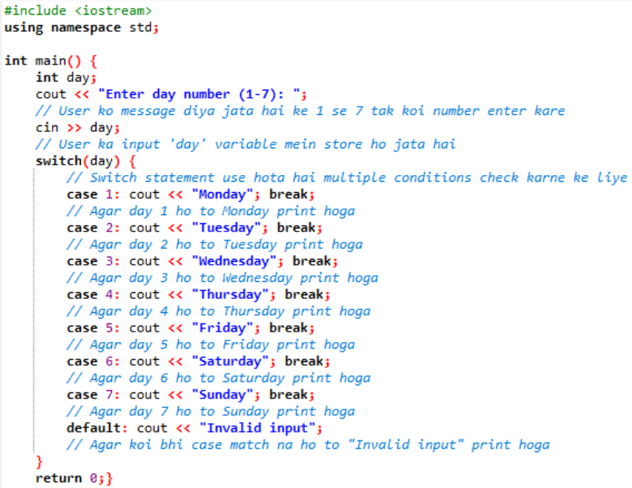

Conclusion:
Conditional statements are essential for controlling the flow of a program and making decisions based on user input or conditions.

Tasks:
(1):
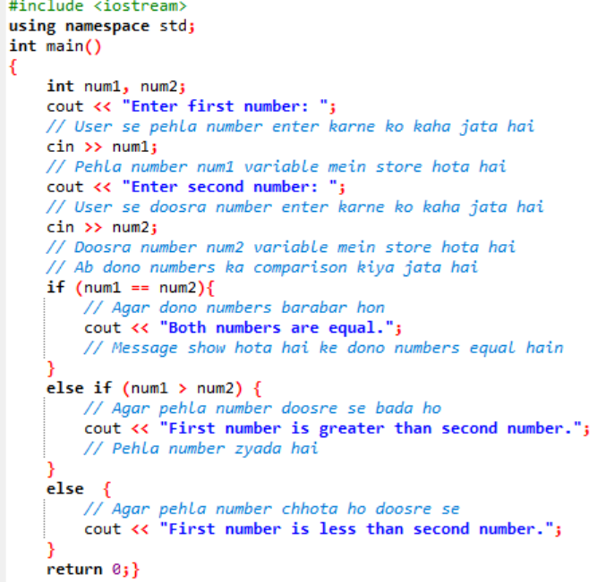
(2):
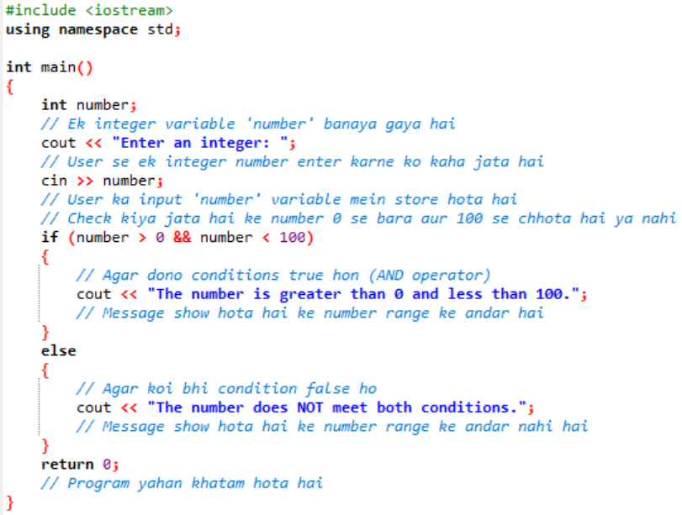

(3):
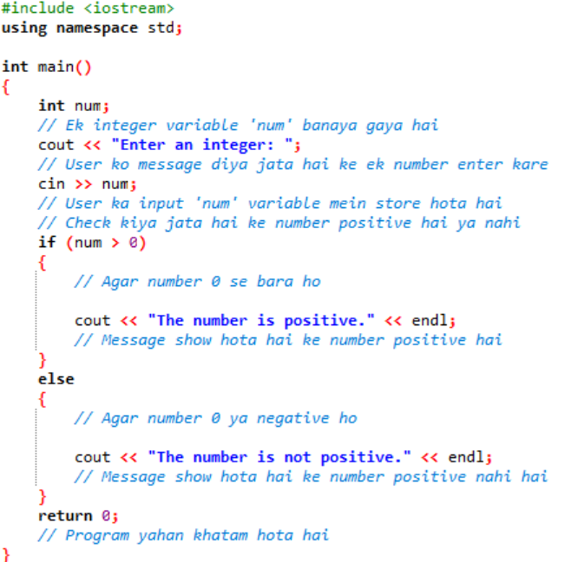
(4):
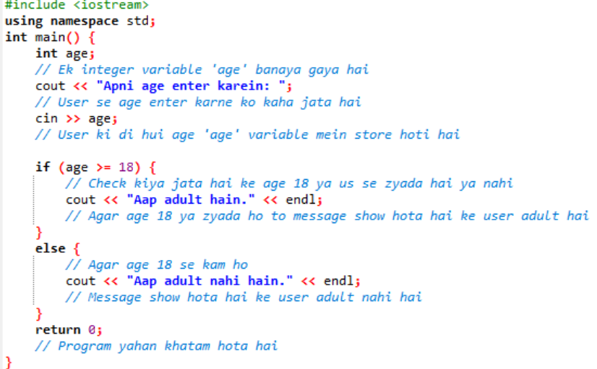
(5):
